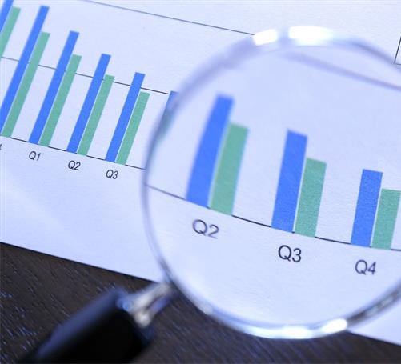**Achieving a successful launch through Data Science**

SRIRAM REDDY

2023-01-26

# OUTLINE

* Executive Summary
* Introduction
* Methodology
* Results
* Visualization – Charts
* Dashboard
* Discussion
* Findings & Implications
* Conclusion
* Appendix

# EXECUTIVE SUMMARY

* Results summary:
* Public domain data was collected with Python scripts
* Data preparation completed to create a viable data source
* Measurements and analysis performed on data source allowed the success/failure rate of launches
* Machine learning techniques were implemented to determine the principal factors to ensure a successful launch.
* Analysis Methodology:
* Web Scrapping and SpaceX API for data collection
* Exploratory Data Analysis (EDA) for data preparation and analytics
* Machine Learning for result predictions.

# INTRODUCTION

* In this project, the process to successfully retrieve the first stage of a rocket launch will be analyzed.
* Determining factors for success will be defined:
* Booster version
* Launch Site
* Orbit
* Payload mass
* Successful rocket launches cost can be reduced in 62 million dollars per event, by reusing the first stage.

# METHODOLOGY – Data Collection and Preparation

* Data Collected from:
* SpaceX API (<http://api.spacexdata.com/v4/rockets()>
* Public records ([List of Falcon 9 and Falcon Heavy launches (2010–2019) –](https://en.wikipedia.org/wiki/List_of_Falcon_9_and_Falcon_Heavy_launches_(2010%E2%80%932019)) [Wikipedia)](https://en.wikipedia.org/wiki/List_of_Falcon_9_and_Falcon_Heavy_launches_(2010%E2%80%932019))
* Steps
* Extraction of SpaceX Launch data
* Data filtering for Falcon 9 launches
* Data preparation in case of missing values
* Extraction of column/variable names from HTML table
* Creation of data frame
* Complete data prep procedure in appendix.

**Data Analysis**

* Exploratory Data Analysis performed on dataset
* Results of:
* Launches per site
* Occurrences of each orbit
* Occurrences of mission outcomes per orbit
* Landing outcome label created
* Data exploration and graphics created to visualize features relationship. Full list of queries in Appendix.
* Payload Mass x Flight Number
* Launch Site x Flight Number
* Launch Site x Payload Mass
* Orbit vs Flight Number
* Payload vs. Orbit
* Folium Interactive Map created
* Markers indicate points like launch sites
* Circles indicate highlighted areas around specific coordinates, like NASA Johnson Space Center
* Marker clusters indicate groups of events in each coordinate, like launches in a launch site
* Lines indicate distances between two coordinates
* Plotly Dashboard
* Graphs and plots created:
* Percentage of launches by site
* Payload range
* Results indicate relationship between factors like payloads and launch sites. This allows identification of **Best place to launch according to payloads**.

# Data Prediction

* Classfication models compared:
* Logistic regression
* Support vector machine
* Decision tree
* K Nearest neighbors

There are 4 main launch sites for Space X.

Average payload for a F9 booster is 2,928 kg.

The first success landing outcome happened in 2017.

The highest success rate for landing on F9 boosters with payloads above the average is drone ships.

Two booster versions failed at landing in drone ships in 2017.

The number of successful landing outcomes improve in time.

Launch sites analysis. Most launches happens at each cost launch sites.

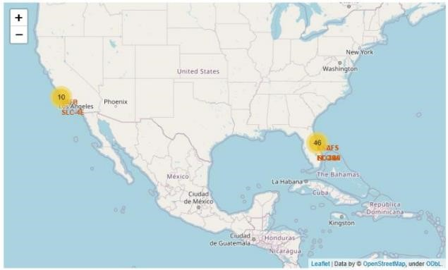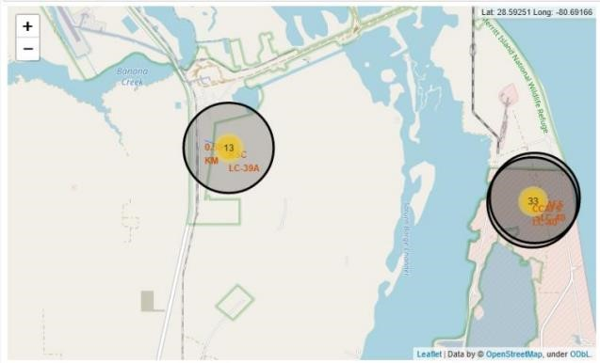

Launch Site VAFB SLC 4E has the best score of all sites. Although the success rate improves in time

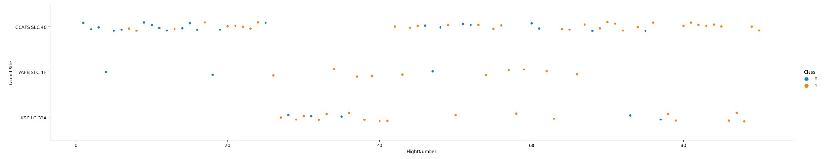

Also the probability of a successful launch is 100% when the Payload mass is over 9000 and under 1400kg.

Payloads over 1200kg are not performed by VAFB SLC 4E launch.

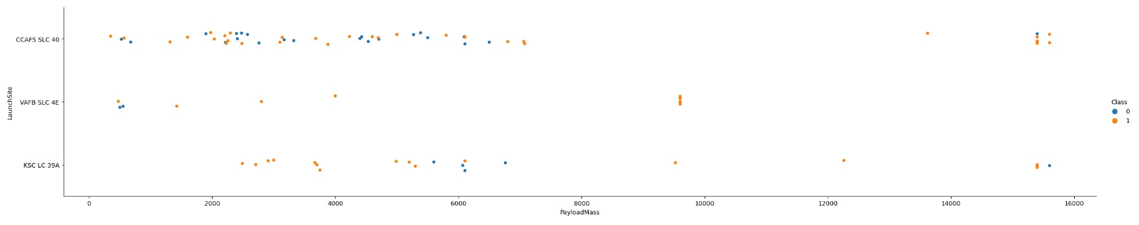

•

The largest success rate are presented in orbits:

•

ES

-

L1

•

GEO

•

HEO

•

SSO

•

Success rate improves over time.

•

The success rate of the better orbits is higher at payload mass under

4000

kg.

•

Orbits HEO and SSO have a low count of launches, so the success rate

is not as reliable.

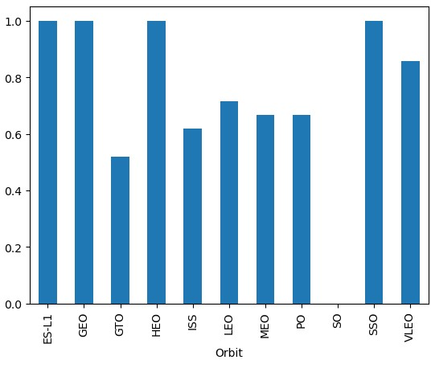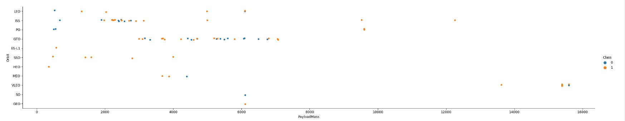

**RESULTS**

Of all

classification

models

tested,

the

Decision Tree Classifier is

the best to predict successful landings, having an accuracy over

87

% in total.

The

accuracy

is

proven

in

the

confusion

matrix

for the Decision

Tree Classifier, by showing the largest numbers of true

positives.

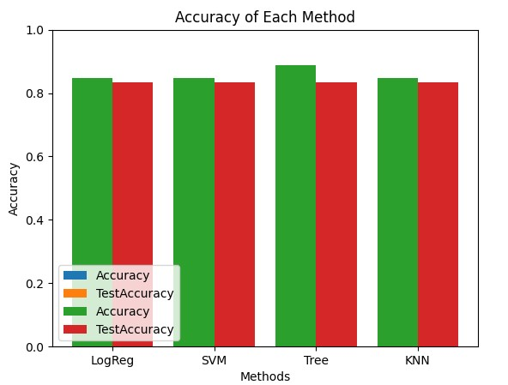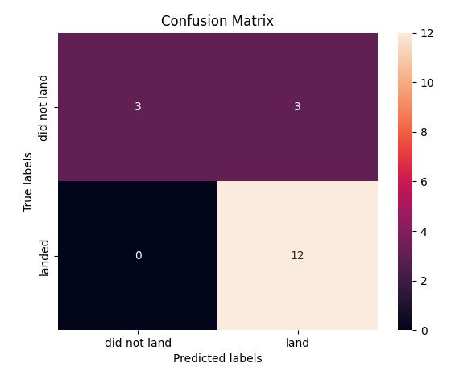

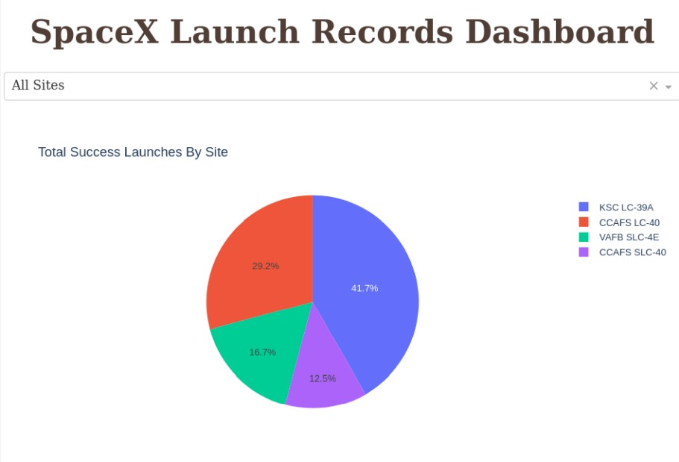The probability of success shows dependency on the Launch Site

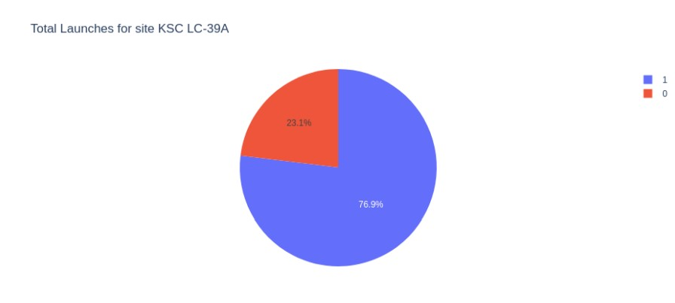When a specific site is selected, its percentage of success/failure can be observed.

In this case, site KSC LC-39A has a 76.9% rate of success.

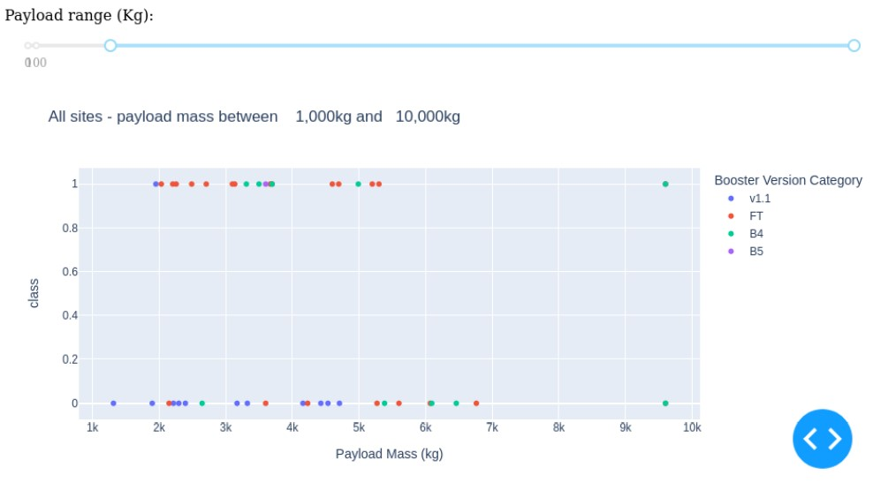It can be observed that the FT boosters have a better success rate in payload masses under 6,000 kgs.

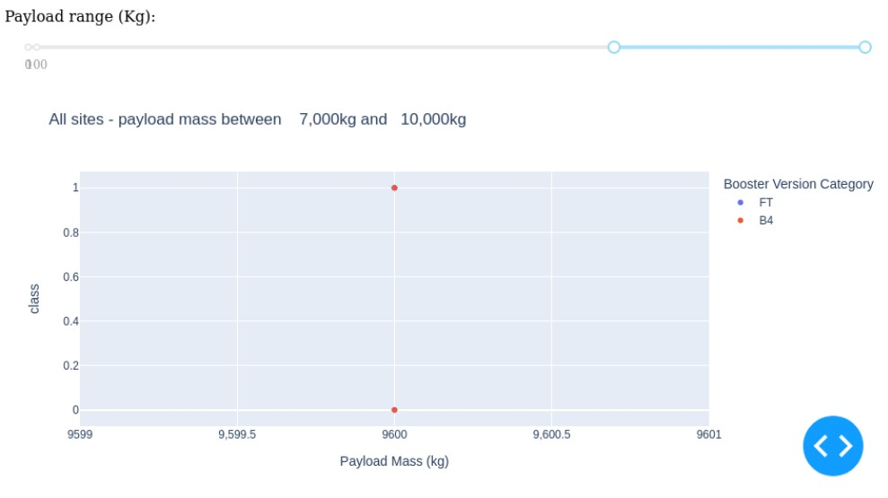There are not enough events to determine the level of success/failure in Launches with a mass over 9,000 kgs.

# CONCLUSIONS

* The best launch site is KSC LC-39A
* There are not enough data about launches over 7,000kg to determine success rates.
* Improvement on rocket launch technologies has increased the success rate over time.
* Decision Tree Classifier can be used to predict successful landings to increase profit.

# APPENDIX

* Appendix I: SQL Queries Summary
* Appendix II: SQL Queries Executed
* Appendix III: Launch Site Maps

# Appendix I: SQL Queries Summary

* Names of the unique launch sites in the space mission
* Launch sites with name starting as ‘CCA’
* Total payload mass carried by bosters launched by NASA
* Average payload mass carried by booster version F9
* Date when the first successful landing is achieved
* Successful booster launches in drone shops and payload mass between 4000 and 6000 kgs.
* Total number of successful and failed mission outcomes
* Booster versions carrying the maximum payload mass
* Failed landing outcomes in drone shop, booster versionas and launch site names
* Rank of landing outcomes

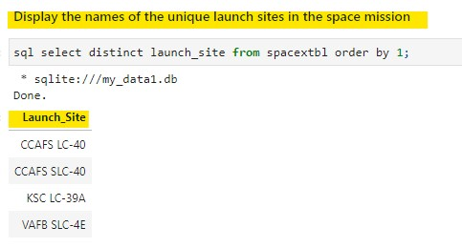

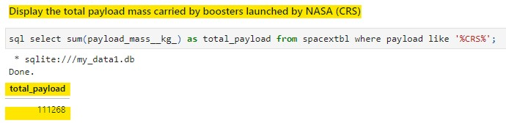

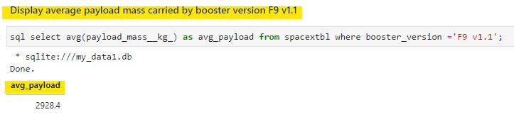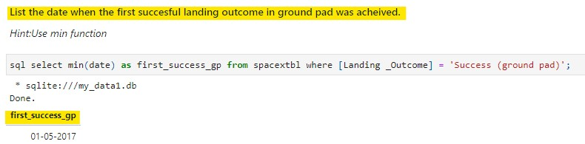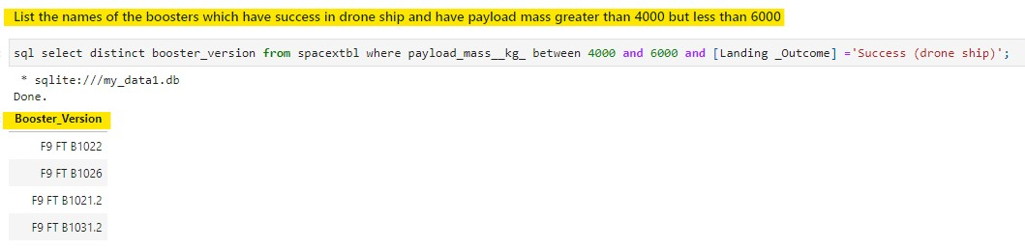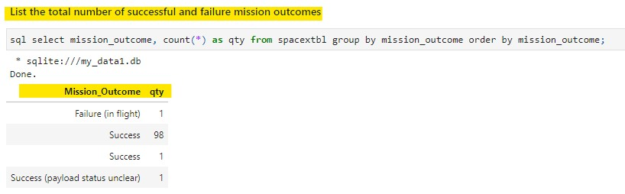

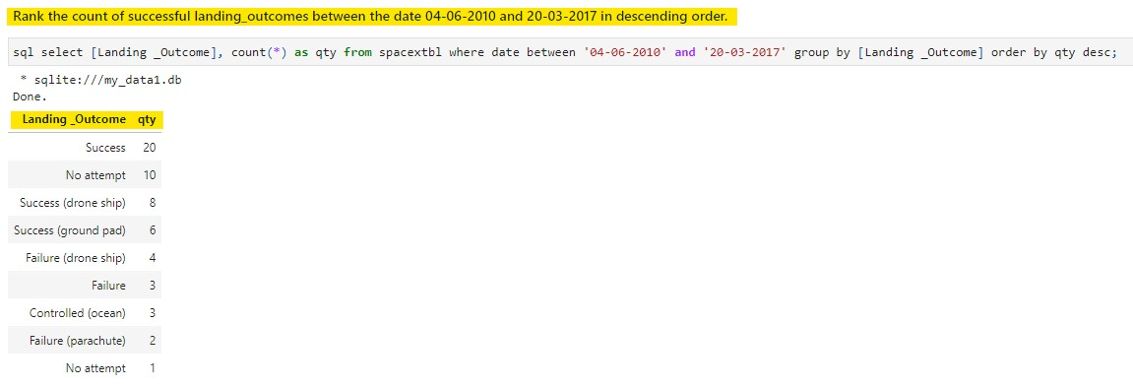

Launch site locations.

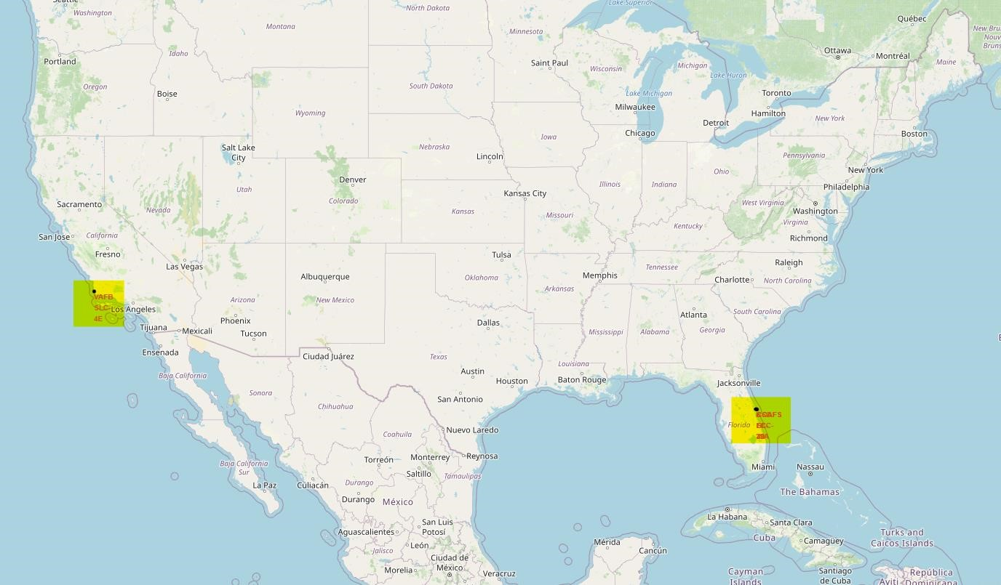

Launch counts by site. And success/fail launch result represented by color green/red on each location.

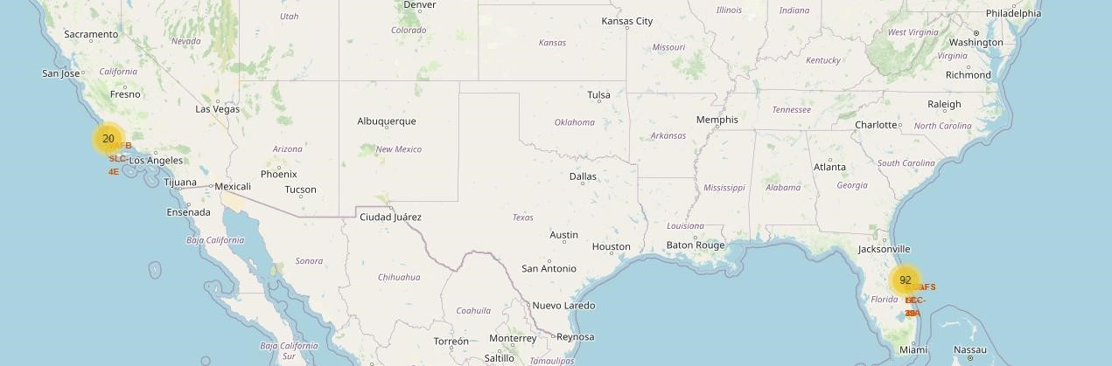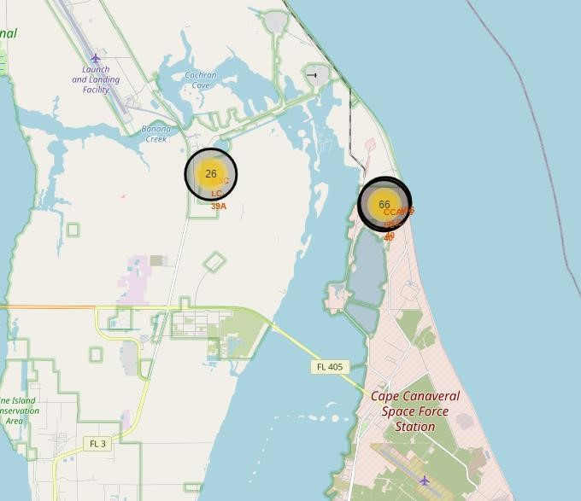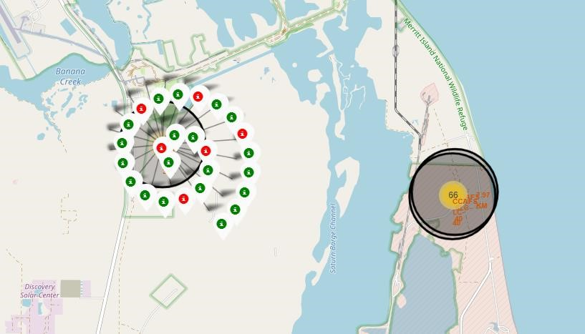

Total distance from habitated zones, rails and roads to reference safety and logistics on launch sites.

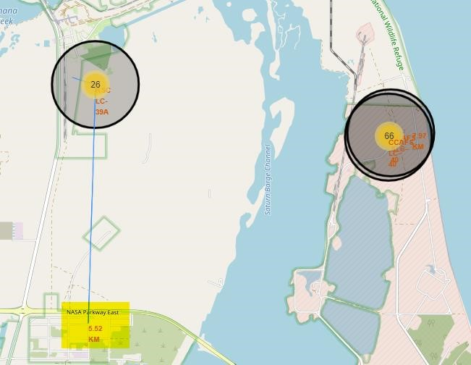

**Thank you!**

© IBM Corporation. All rights reserved.